**Assignment Day 10 | July 17**

**Question:**

Construct 10 Hypothesis from the Attrition Problem given on Day 7 Assignment

**Problem Statement:**

A large company named XYZ, employs, at any given point of time, around 4000 employees. However, every year, around 15% of its employees leave the company and need to be replaced with the talent pool available in the job market. The management believes that this level of attrition (employees leaving, either on their own or because they got fired) is bad for the company, because of the following reasons -

The former employees projects get delayed, which makes it difficult to meet timelines, resulting in a reputation loss among consumers and partners A sizeable department has to be maintained, for the purposes of recruiting new talent More often than not, the new employees have to be trained for the job and/or given time to acclimatise themselves to the company

Hence, the management has contracted an HR analytics firm to understand what factors they should focus on, in order to curb attrition. In other words, they want to know what changes they should make to their workplace, in order to get most of their employees to stay. Also, they want to know which of these variables is most important and needs to be addressed right away.

Since you are one of the star analysts at the firm, this project has been given to you.

Goal of the case study You are required to model the probability of attrition. The results thus obtained will be used by the management to understand what changes they should make to their workplace, in order to get most of their employees to stay.

**Answer:**

We are going to frame the Hypothesis Statement based on the Mean, Standard Deviation, IQR obtain from the describe function of pandas in a Data frame as below:

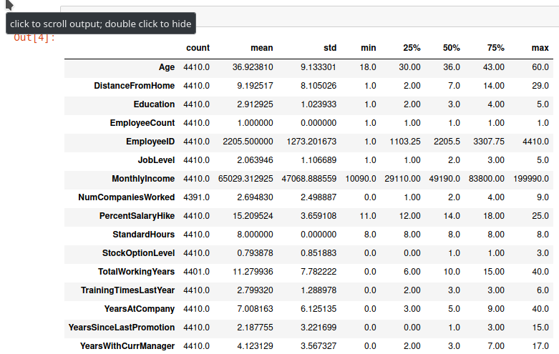

**From the above details we can set Hypothesis Statements as below:**

1. Age above 60 have high employee atrrition rate
2. Years at Company above 7 has higher employee attrition rate
3. Marital Status is not associated with Employee Attrition
4. Employee Attrition is not related to Department of the employee
5. Employee who didn't got any promotion for last 2 years have higher rate of attrition
6. Average Salary of attrition employee is greater than 61000
7. Percentage Salary Hike of attrition employee is greater than 15
8. Employees who have worked in more than 2 companies have higher attrition rate
9. Female employees have higher employee attrition rate
10. Married Female have higher employee attrition rate